JUnit Testing Exercises
Exercise 1: Setting Up JUnit Scenario: You need to set up JUnit in your Java project to start writing unit tests.
Steps:
1. Create a new Java project in your IDE (e.g., IntelliJ IDEA, Eclipse).
2. Add JUnit dependency to your project. If you are using Maven, add the following to your pom.xml: junit junit 4.13.2 test
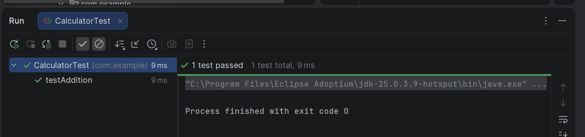
3. Create a new test class in your project.

Exercise 3: Assertions in JUnit Scenario: You need to use different assertions in JUnit to validate your test results.
Steps:
- Write tests using various JUnit assertions.
- Solution Code:
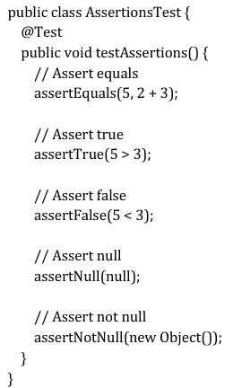
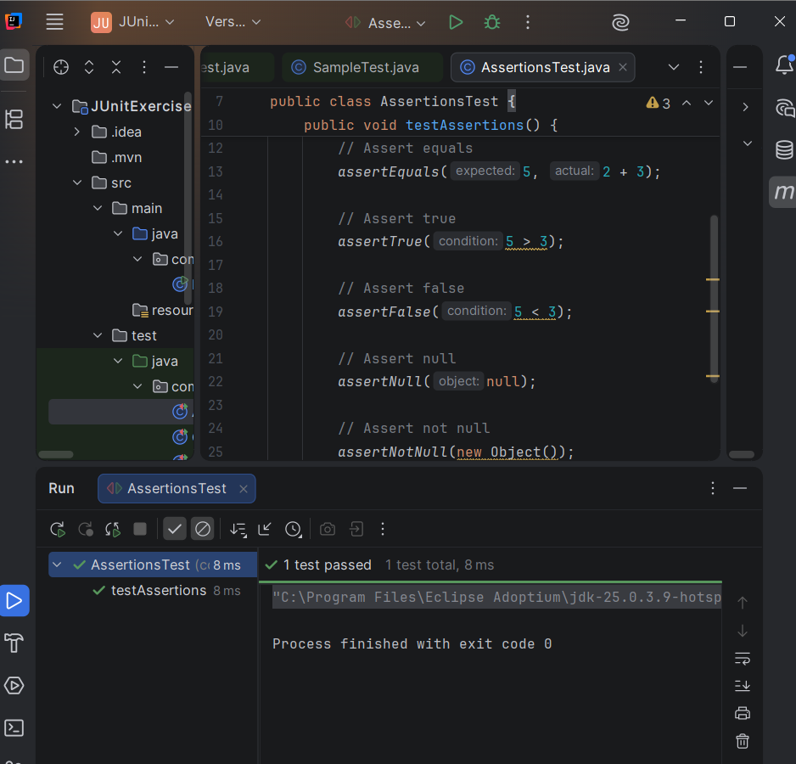

Exercise 4: Arrange-Act-Assert (AAA) Pattern, Test Fixtures, Setup and Teardown Methods in JUnit Scenario:
You need to organize your tests using the Arrange-Act-Assert (AAA) pattern and use setup and teardown methods.
Steps:
1. Write tests using the AAA pattern.
2. Use @Before and @After annotations for setup and teardown methods.
